+

-[Cse 326 Project Report - html programme](https://www.studocu.com/in/document/lovely-professional-university/html-and-css/cse-326-project-report-html-programme/32871824?utm_campaign=shared-document&utm_source=studocu-document&utm_medium=social_sharing&utm_content=cse-326-project-report-html-programme)

HTML and CSS (Lovely Professional University)

# PROJECT REPORT

(Project Term Aug - December 2022)

*SPORTS CLUB WEBSITE*

Submitted by

**Name:- VIJAY KUMAR REDDY MOPURI Registration Number :** **12224196**

**Name:- YASH PODDAR Registration Number :12224180**

**Name:- KRISHNA PRADHAN Registration Number:12224021**

**Course Code :- CSE 326**

*Under the Guidance of :- Aashima mam*

**School of Computer Science and Engineering**



**DECLARATION**

We hereby declare that the project work entitled (<SPORTS CLUB WEBSITE=) is an authentic record of our own work carried out as requirements of Capstone Project for the award of

B.Tech degree in __B.Tech (cse)__________(Programme Name) from Lovely Professional University, Phagwara, under the guidance of (Aashima mam), during Jan to April 2022. All the information furnished in this capstone project report is based on our intensive work and is genuine

Name of Student 1: VIJAY KUMAR REDDY MOPURI

Registration Number: 12224196

Roll number:- RKOC50A10

Name of Student 2: YASH PODDAR

Registration Number: 12224180

Roll Number:- RKOC50A16

Name of Student 3: KRISHNA PRADHAN

Registration Number: 12224021

Roll Number:- RKOC50A36

*SPORTS CLUB WEBSITE*

# *ABSTRACT:*-

*The main motive of our sports club is a good quality of training, practice to our members. We designed a website address for this club to find out on the website and in which various sports are listed to choose from.*

## ACKNOWLEDGEMENT:-

*We would like to thank sincerely to our lecturer Aashima mam for teaching with good examples and giving us advice and for input. Also, we would like to thank you my friend for working together and spending lots of time on this project with brilliant ideas.*

# *TABLE CONTENT*

|  |  |  |
| --- | --- | --- |
| *S.No* | *TOPICS:-* | *PAGE NO:-* |
| *1* | *ABSTRACT* | 3 |
| *2* | *INTRODUCTION*   * *CONTEXT* * *IDEA* | 5 |
| *3* | *TEAM MEMBERS* | 6 |
| *4* | *RESULT (Screenshots)* | 7 -11 |
| *5* | *CODE* | 12-21 |
| *6* | *ABOUT*  *SPORTS CLUB WEBSITE* | 22 |
| *7* | *CONCLUSION* | 23 |
| *8* | *REFERENCE* | 23 |

## *INTRODUCTION:- CONTEXT:-*

*This little project has been done as a part of my course for the CSE at Lovely Professional University. Supervised by Aashima mam.*

*IDEA:-*

*It has been the first experience doing such a tiny project full of creative interest. We wanted to make our project an attractive website with creativity, we used different programming processes like HTML for creating a basic website, and to get a radiant look we used CSS part and for design stylishly the web. These programming processes are easy to approach and understand the coding.*

TEAM MEMBERS:

*VIJAY :-*

*CONTRIBUTION:-*

1. *Coding(joined)*
2. *Report*

*KRISHNA :-*

*CONTRIBUTION:-*

1. *Coding(joined)*
2. *Report*

*YASH :-*

*CONTRIBUTION:- –*

* 1. *Coding(joined)*
  2. *Report*

*RESULTS (screenshot):*

*HOME:-*

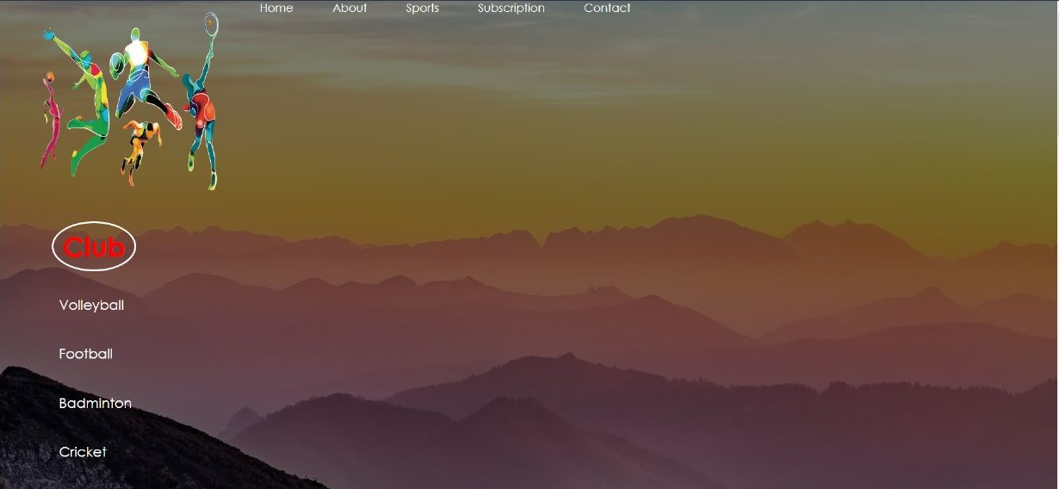

*ABOUT US:-*

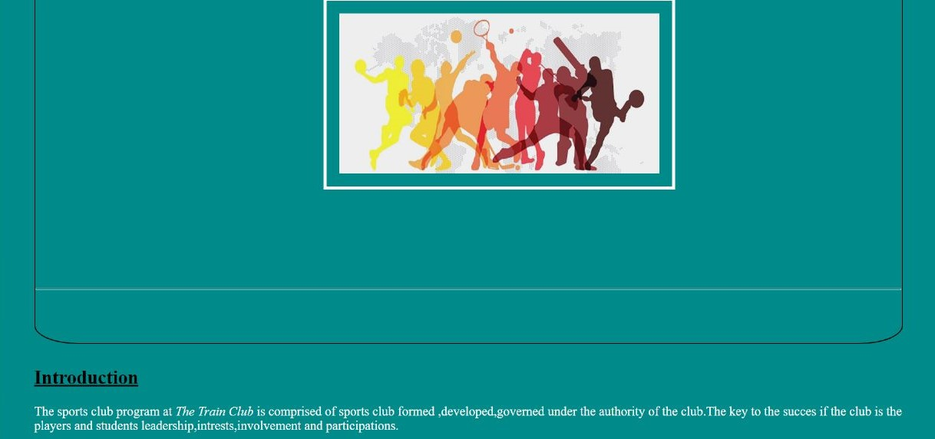

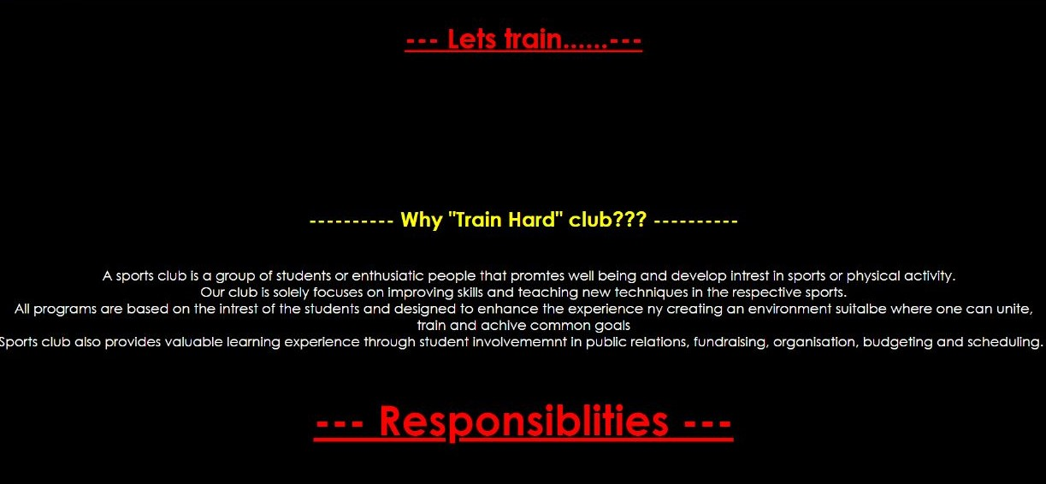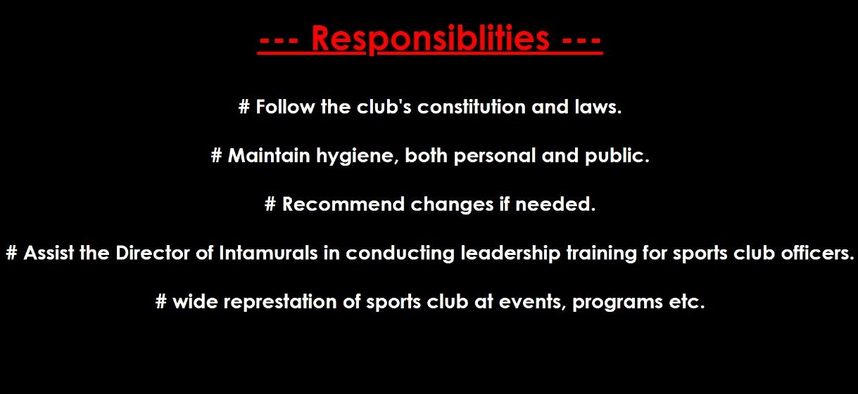

*CLUBS :-*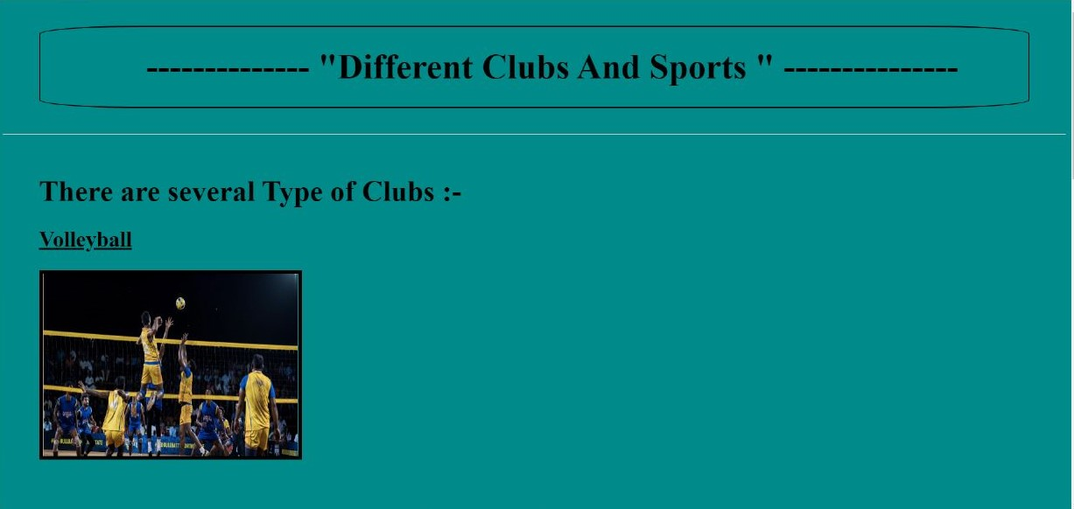

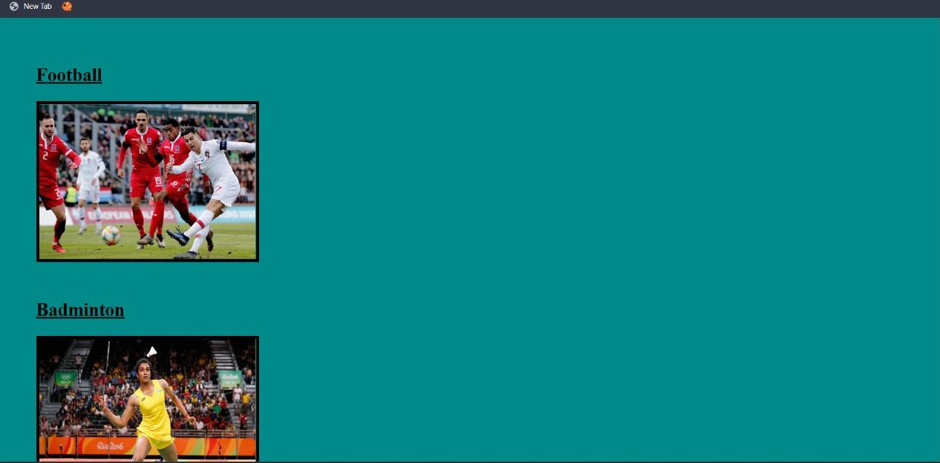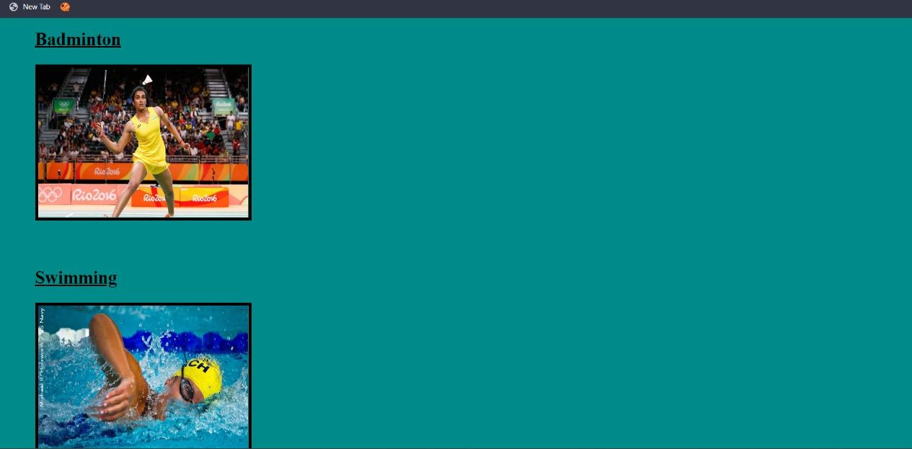

*REGISTRATION :-*

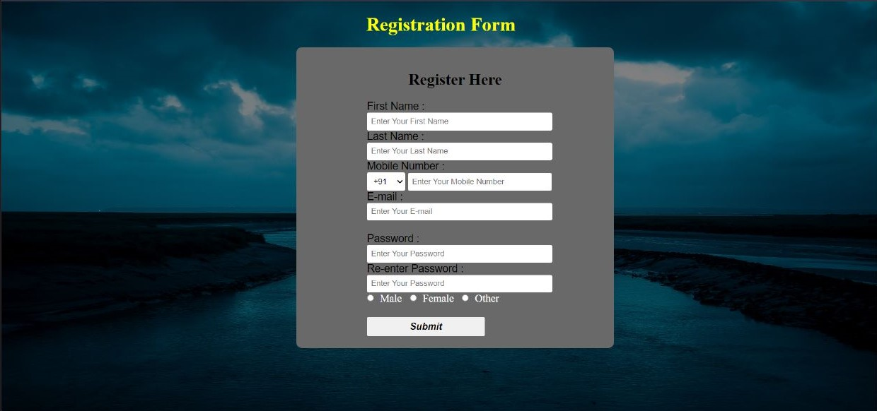

*CONTACT US :-*

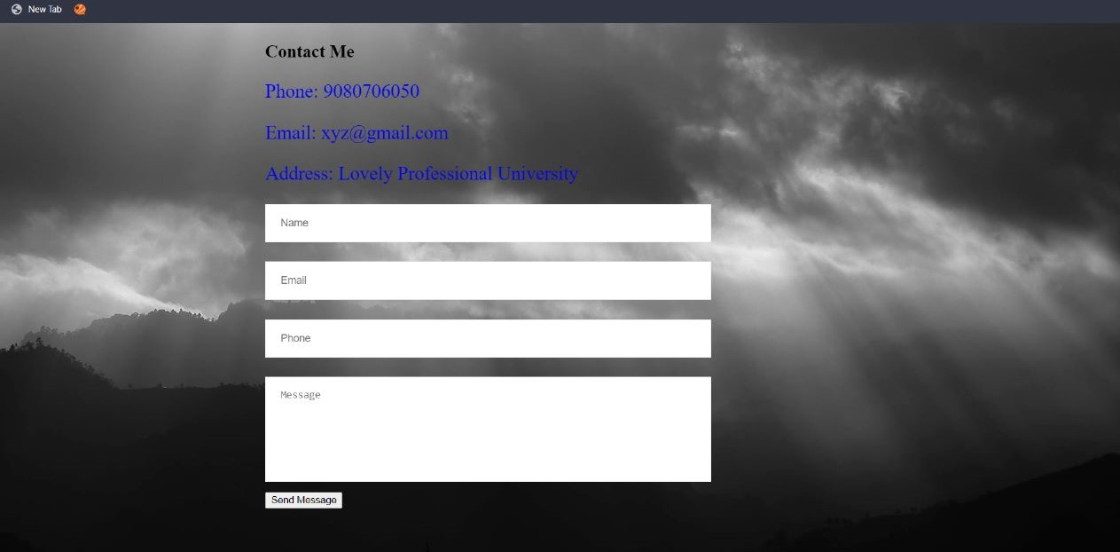

## *CODE:-*

*(HTML part)*

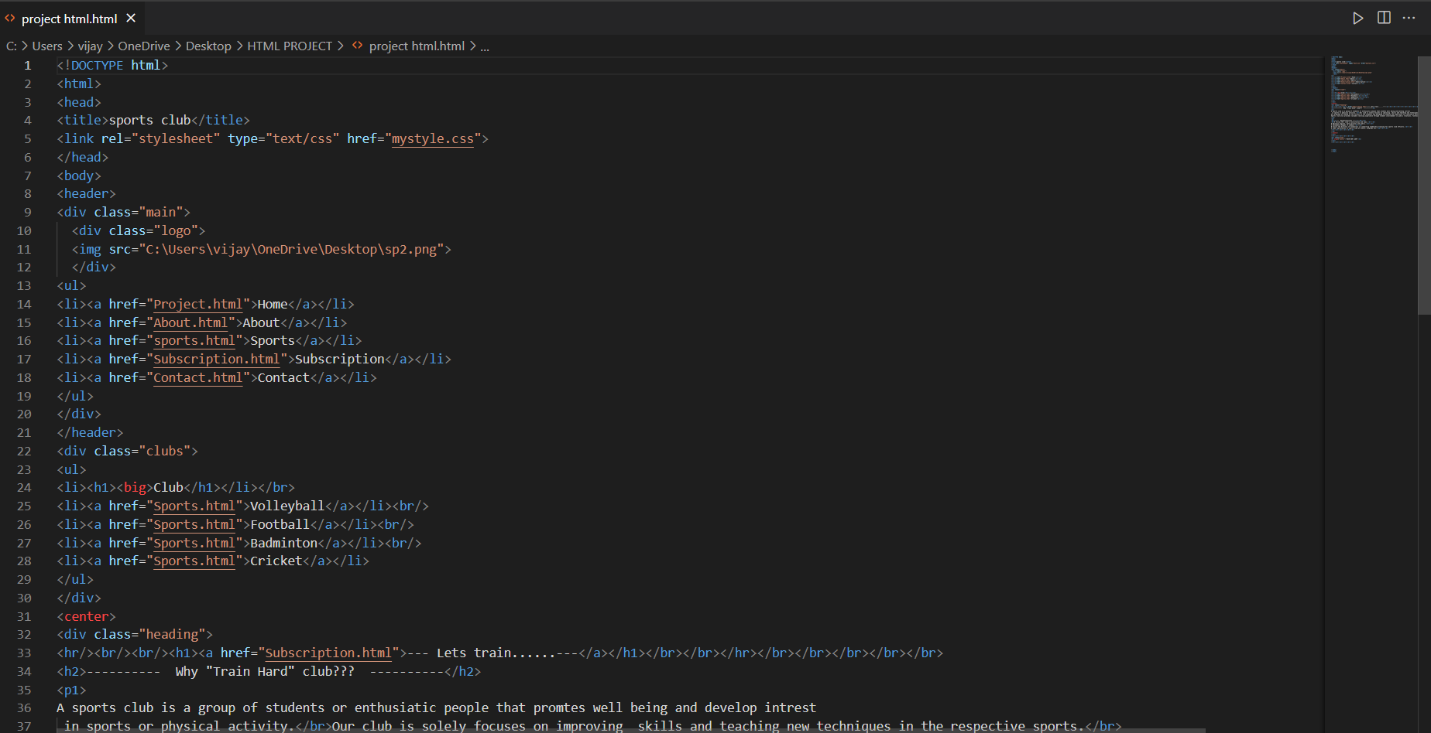

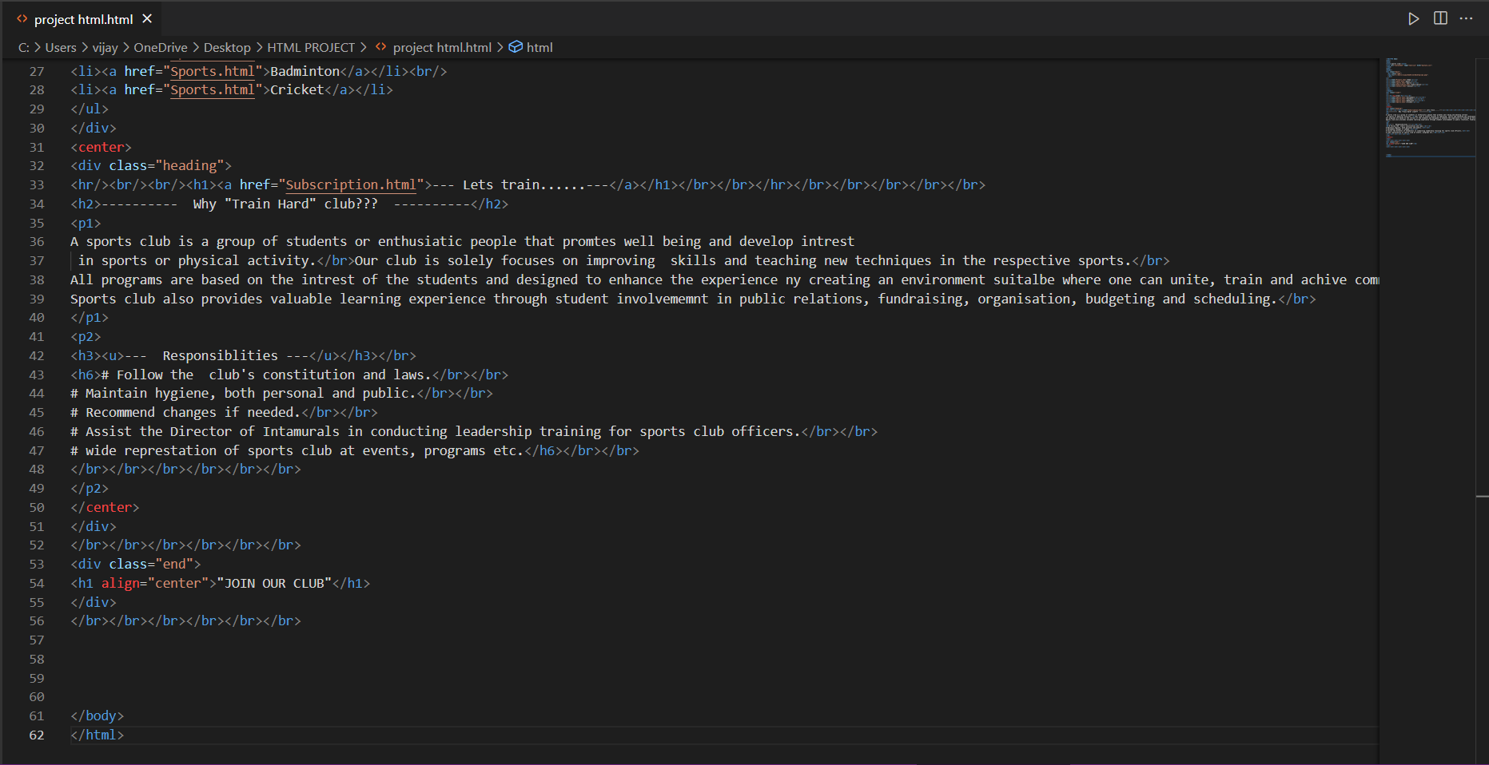

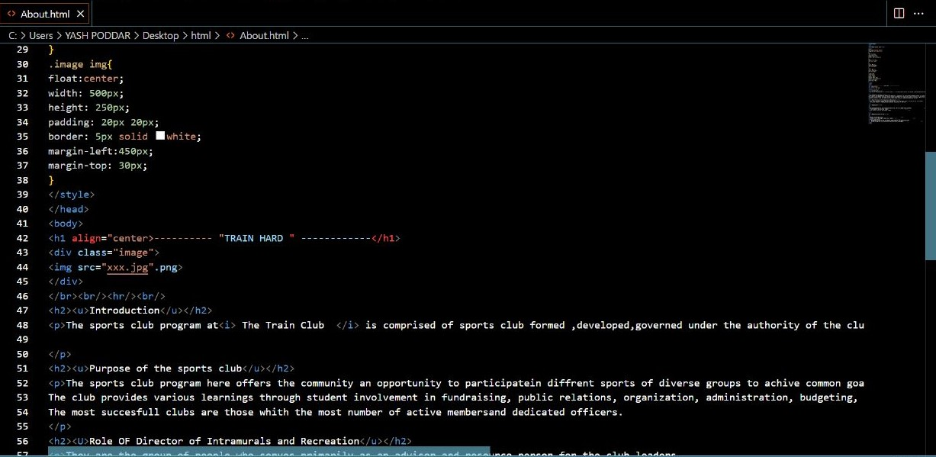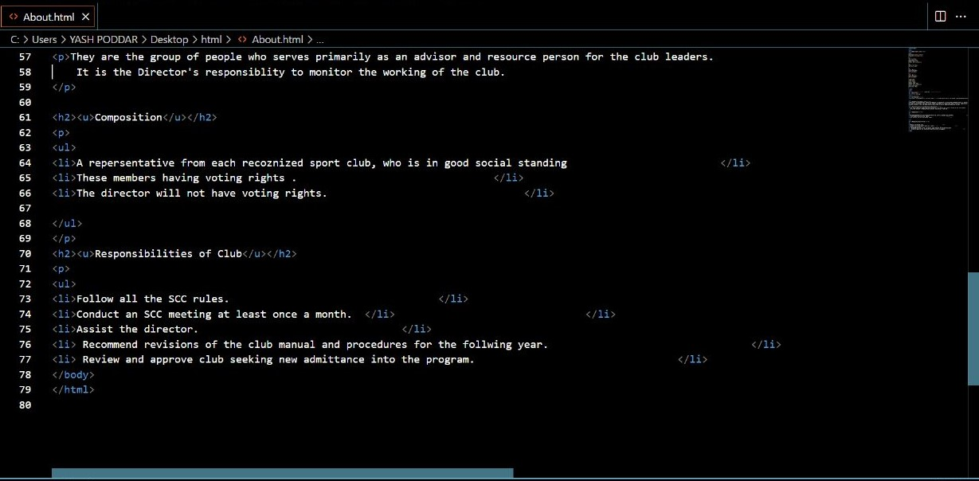

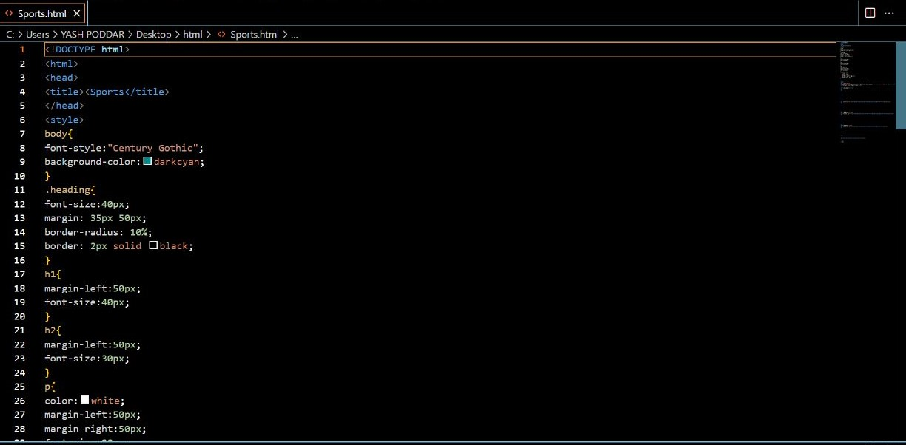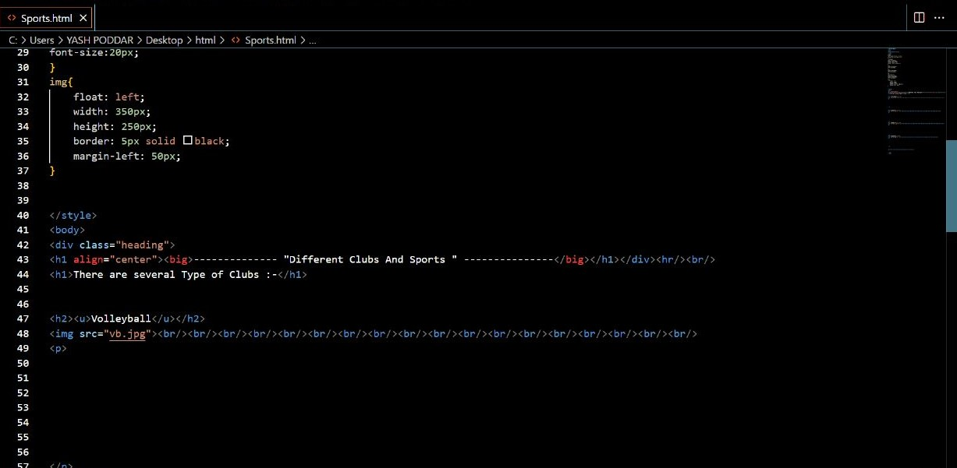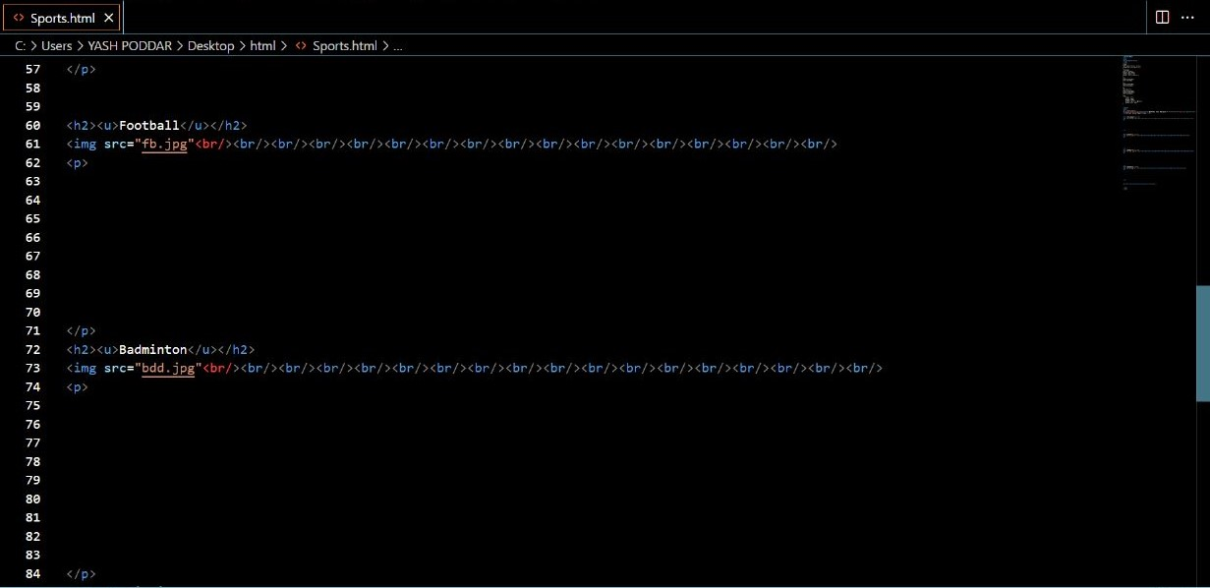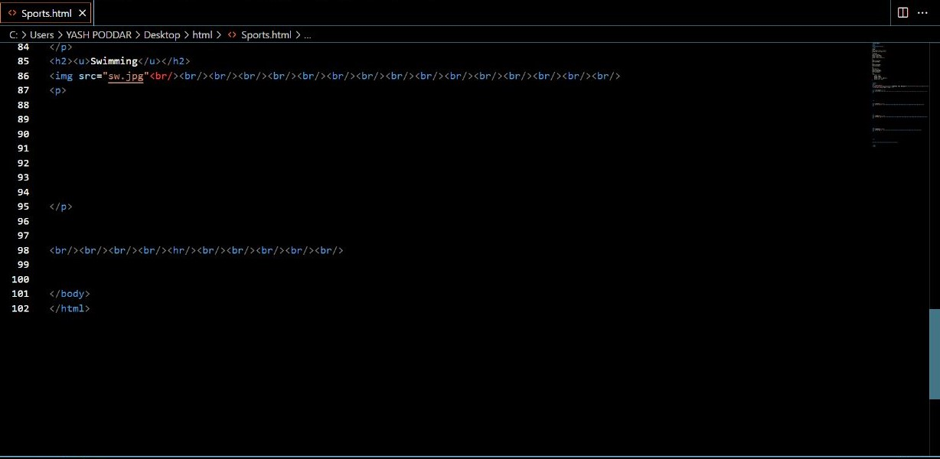

*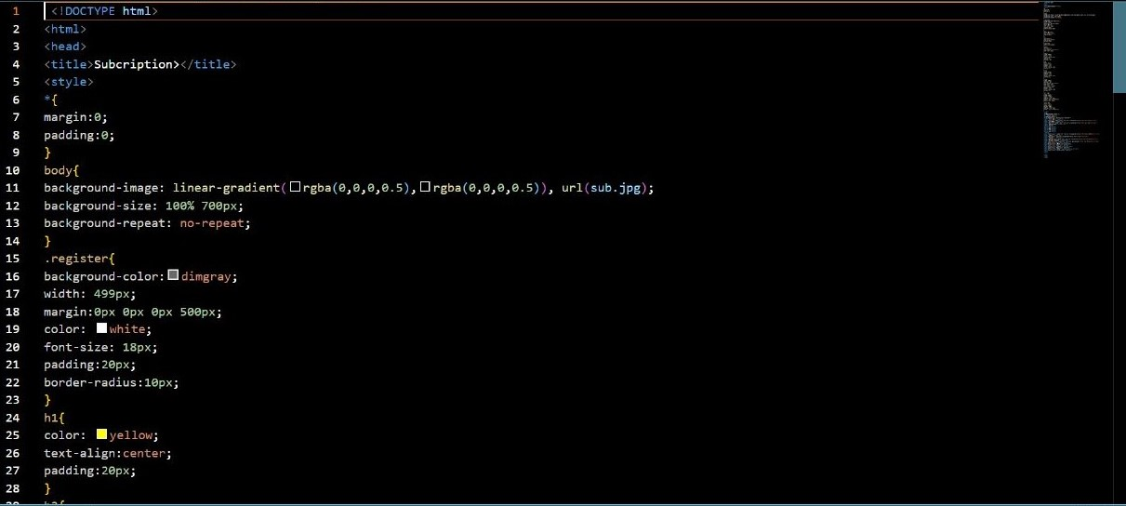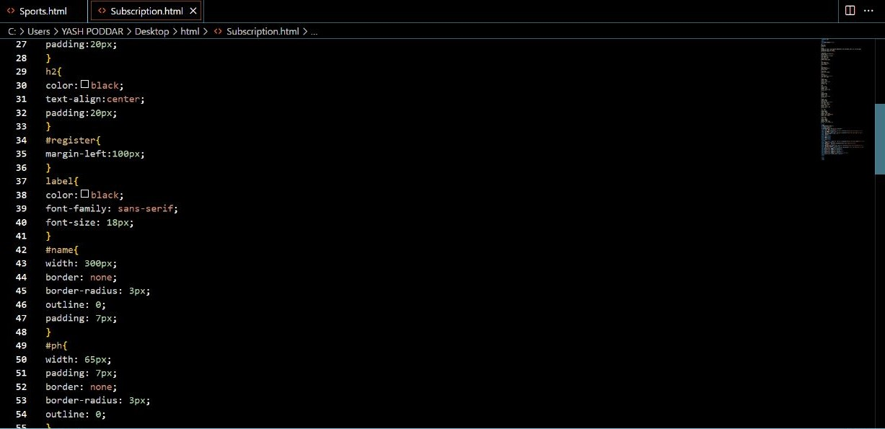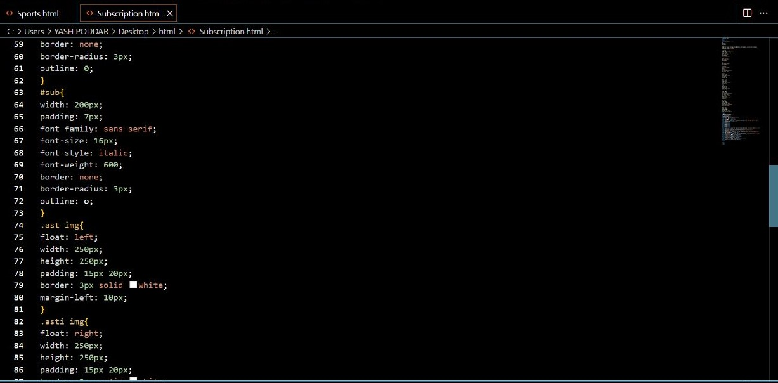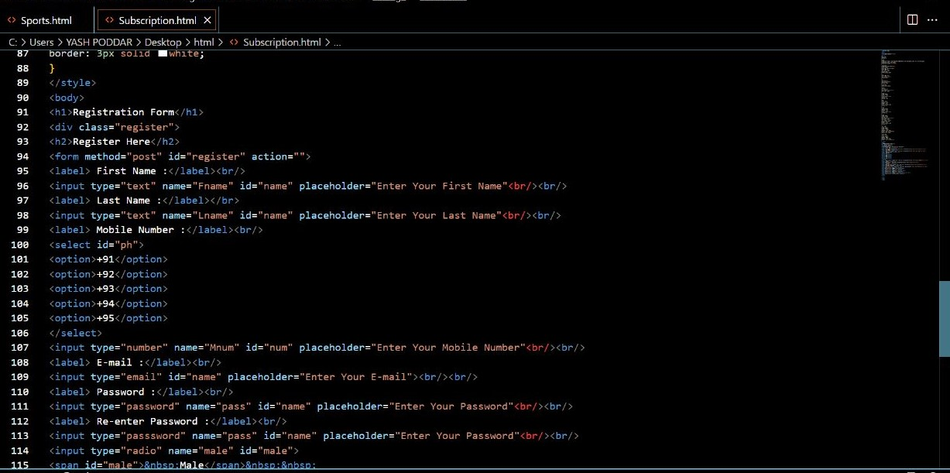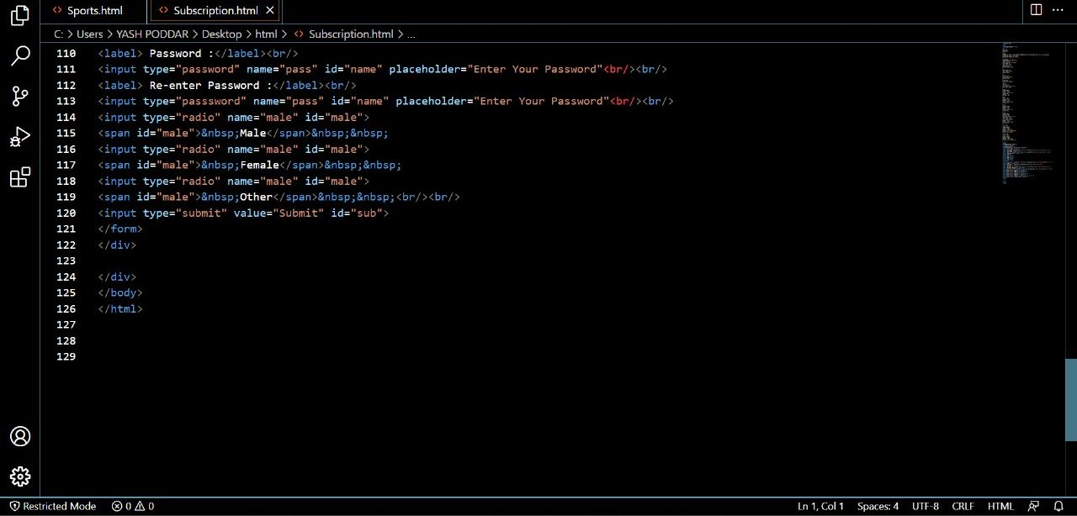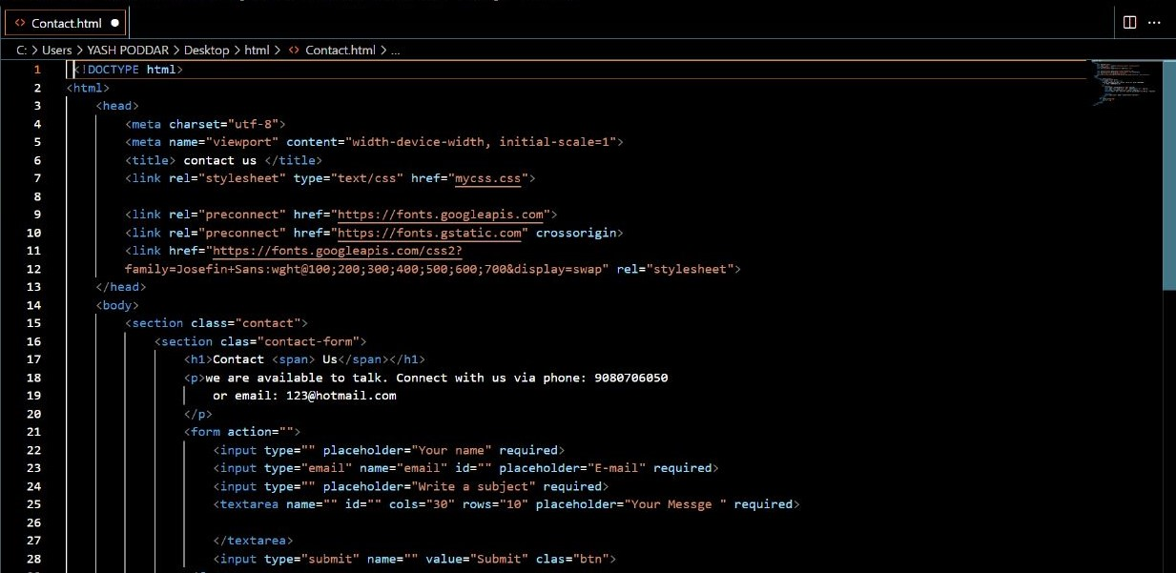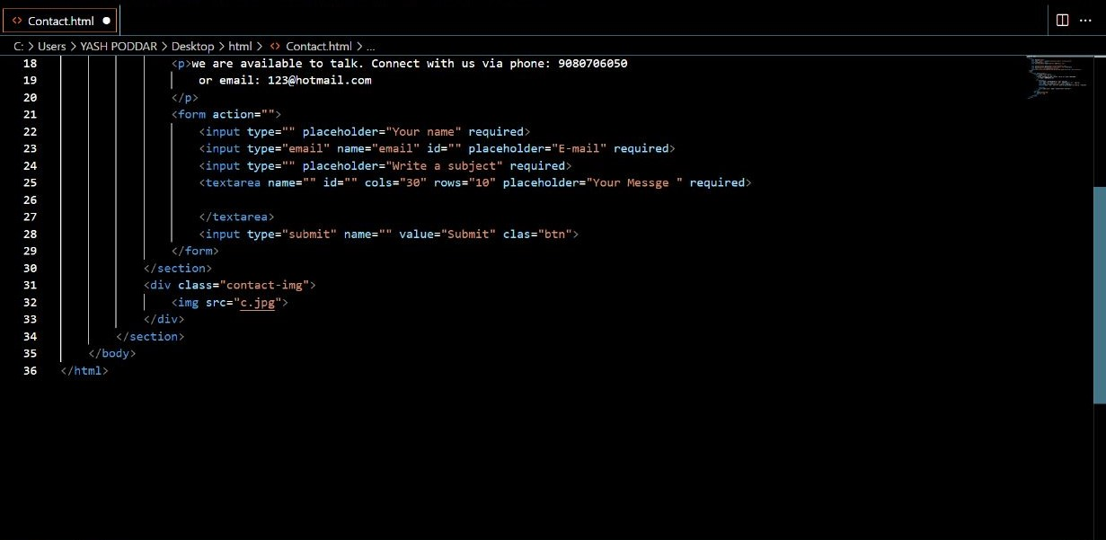CSS PART:-*

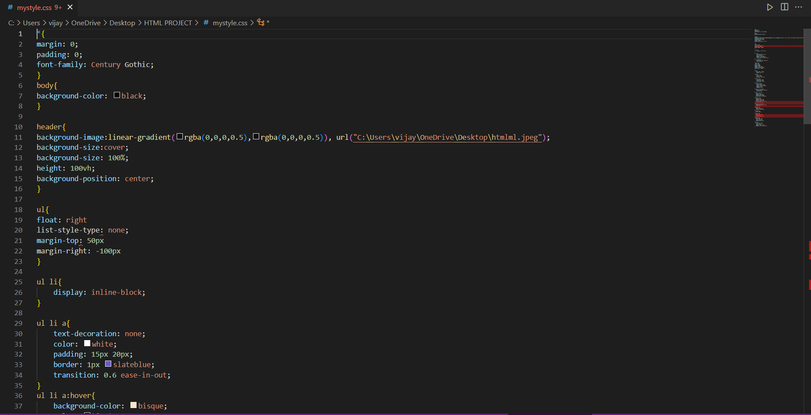

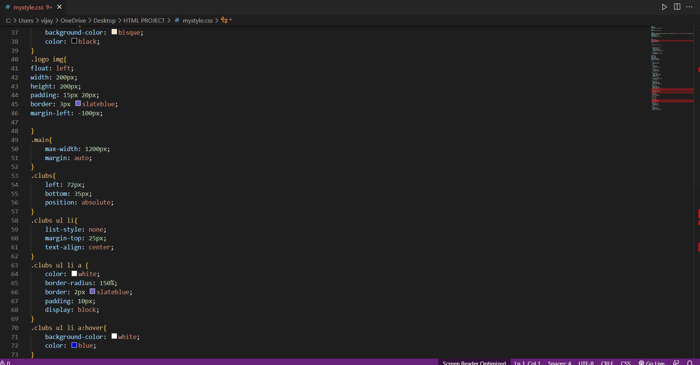

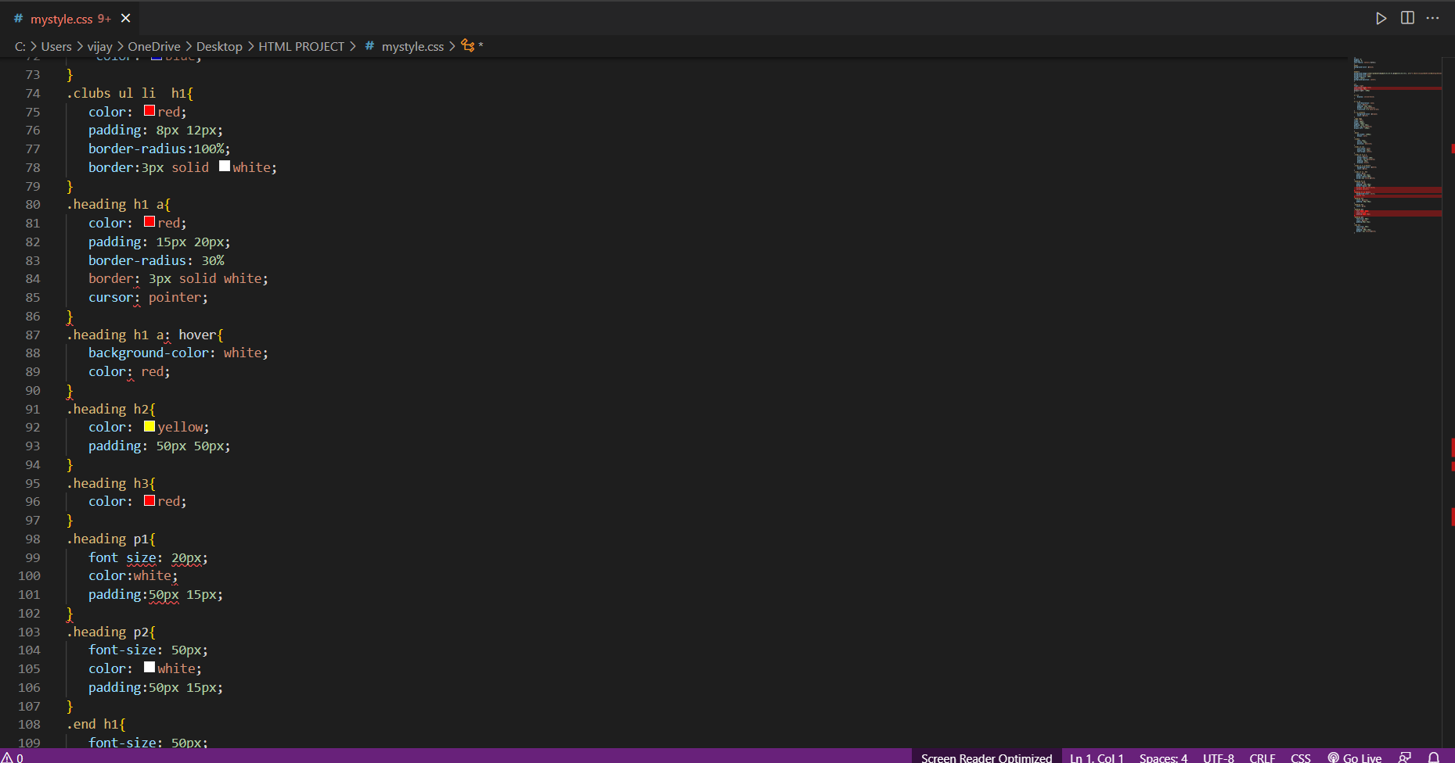

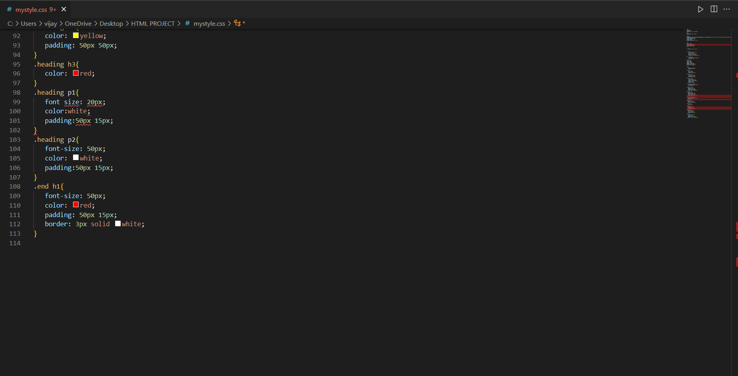

*ABOUT THE SPORTS CLUB WEBSITE :*

*To successfully design content for a SPORTS CLUB website, there are 2 scenarios we have to consider two scenarios to craft and organizing the content.*

*To know about the club, those who know about the brand and who don’t know about the brand can easily visit the website. This club provides training of the highest quality, embracing the skilled and genuinely good regional trainers.*

*It’s a concept to be a multi-sports training center under one roof. It includes sports like volleyball, football, swimming, cricket etc. The achievement of our members is the best result for us.*

*We have experienced trainers, who are experts in their respective sports.*

*We are welcoming with great enthusiasm to see yourself change both physically and mentally.*

### CONCLUSION:-

*This has proven the importance of the website for the improvement of the sports website. As this is another technologies, it is the best way to save and protect nature and it solution to save paper and hardboards in club documentation. Because technology is developing day by day with wonderful is something advanced and less time to use from a website.*

*It is our team hoping this mini-project can make inspire and help you and your customers. Our little project has lots of benefits for the upcoming future*

### REFERENCE:-

*1)YOUTUBE*

*https://www.youtube.com/*

*2)w3schools* [*https://www.w3schools.com/*](https://www.w3schools.com/)

*3)Geeks for greeks*

[*https://www.geeksforgeeks.org*](https://www.geeksforgeeks.org/)[*/*](https://www.geeksforgeeks.org/)

*THANK YOU*